The first antenna we’ll be talking about in detail is the canted turnstile array ~~located opposite the helical antenna in this picture.~~

The canted turnstile array consists of four monopoles oriented at 90 degree intervals. The poles are separated by some center distance, d, and tilted at an angle, alpha, from the top plane of the satellite. ~~Here’s a side view to help you picture it a little better.~~

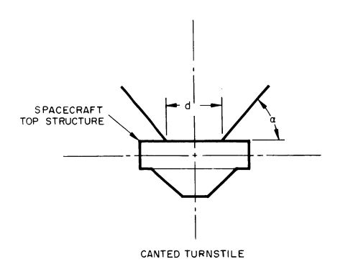

This configuration was chosen by our sponsors because it allows for omnidirectional communication with the satellite which is important because when Oresat is released for the international space station it will be flying, uncontrolled, through low earth orbit and could be in any orientation at any time.

Once deployed, the initial purpose of the turnstile antenna is to begin communication with the ground so they can stabilize the satellite and initiate satellite operations. This means that the deployment of the turnstile is absolutely critical for the success of the mission.

**Constraints**

-Able to be stowed for up to 6 months and still deploy reliably

-Able to withstand harsh launch and orbital environments

-2 poles (0 and 180 deg elements) to be **140mm** in length

-2 poles (90 and 270 deg elements) to be **190mm** in length

-Deploy between 15 and 60 degrees off the plane

1. -Fit on the end cap

-stow to 7mm height

(this option was initially strongly prefered due to the fact that it would enable an

additional card slot for other satellite systems.)

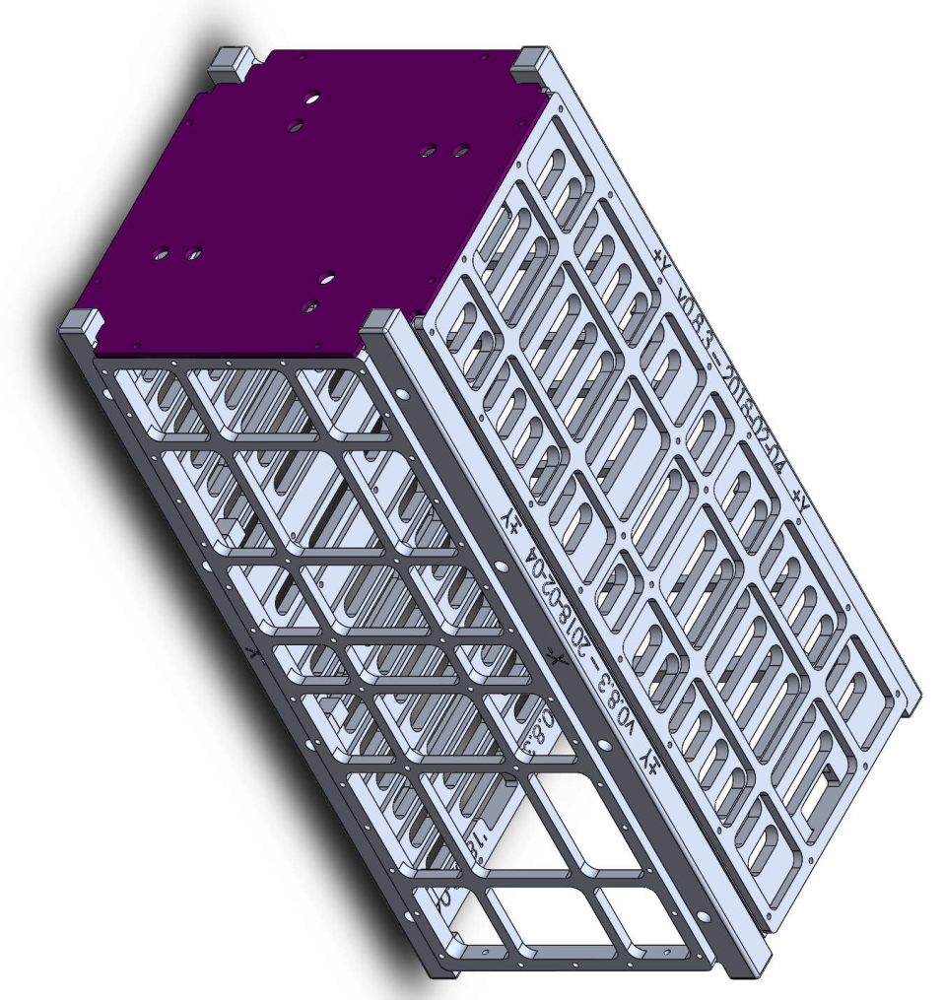

Or

2)-Fit on end card

-stow to under 17mm

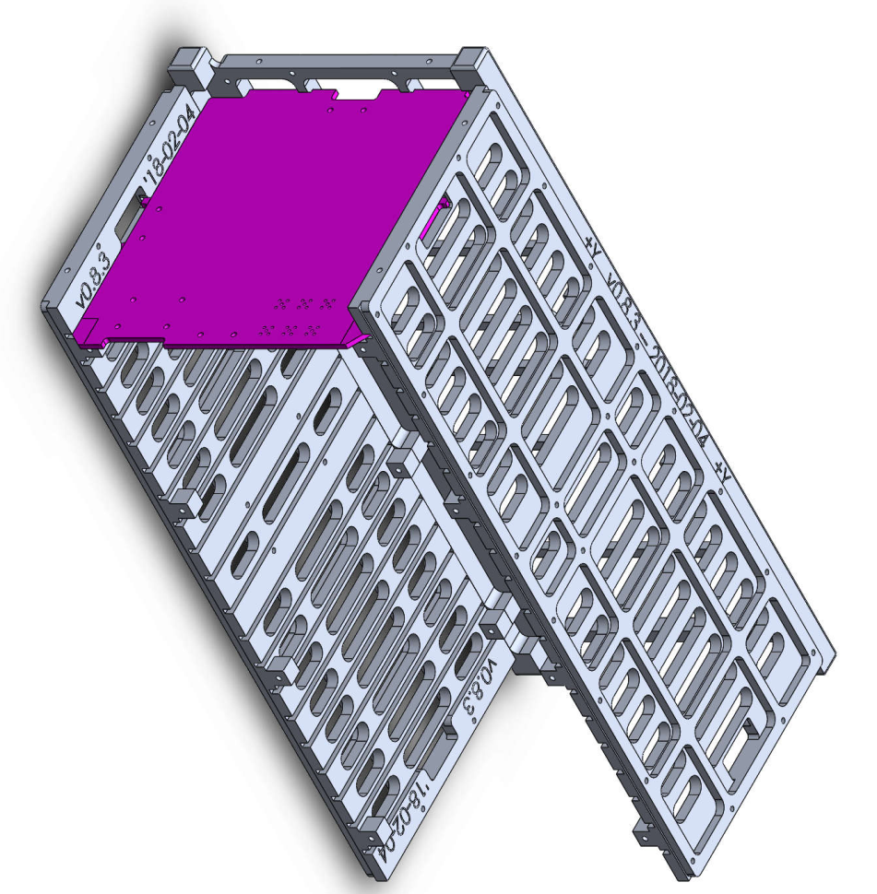

Weight and power wasn’t as important for our capstone but we did attempt to take them into account and minimize each where we could.

**Inspiration**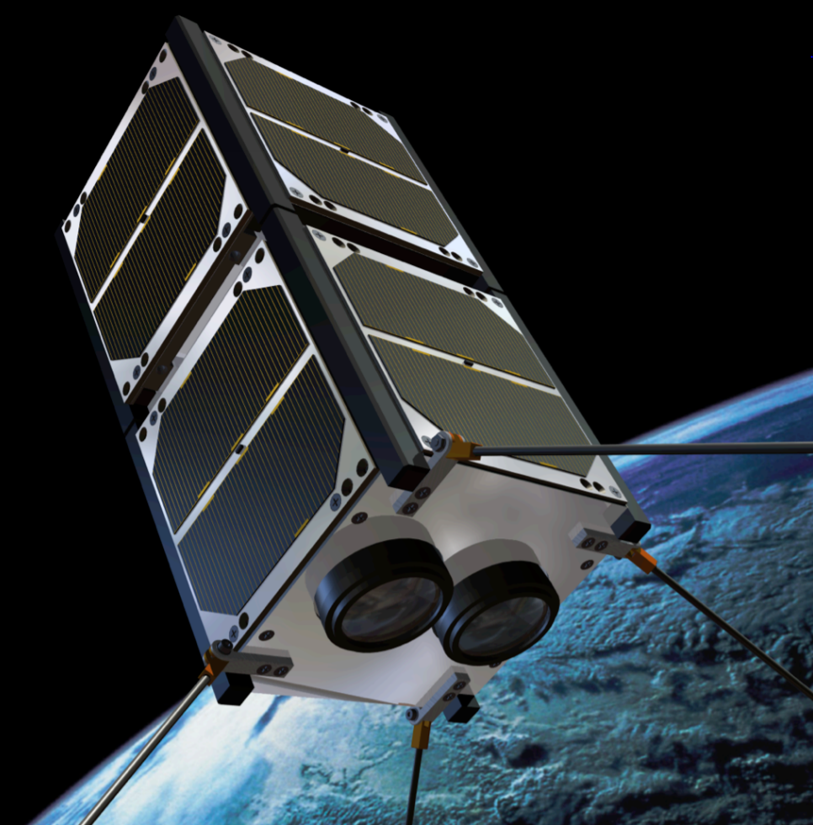

We began by researching current antenna deployment systems available for cube satellites and came across two promising designs. The first was this one: this is the NanoCom ANT 430 that’s manufactured and sold by GOMspace. This particular one folds outward and down over the sides of the satellite and is stowed on the outside which doesn’t work for Oresat because the entire outside of the cubesat is covered in solar panels that could be damaged by the antenna poles laying on top of them. This off the shelf part was also very costly at over $5000 and didn’t match with the goal of Oresat to be completely open source as it’s a commercial part.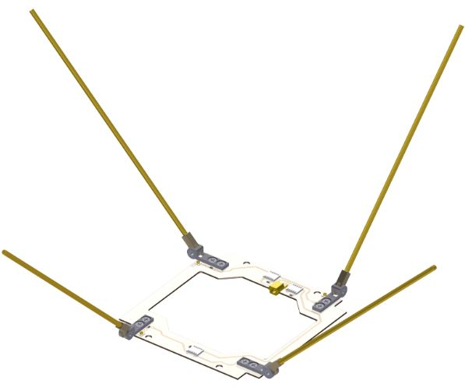

The other design that was promising came from the ELFIN cubesat. This cubest was designed by UCLA and achieves the canted turnstile configuration using rolling tape springs made of fiberglass fabric and epoxy resin with an embedded beryllium copper strip for the conductive element.

This is the deployed antenna on the ELFIN cubesat. and this is the stowed configuration before deployment. The main challenge in this design is that they are using a bonus space on top of their cubesat known as the “tuna can” that basically adds a cylinder to the allocated space of a standard cubestat. Our antenna would be constrained to a much shorter space, but our poles are also much shorter than theirs so we thought we could make it work.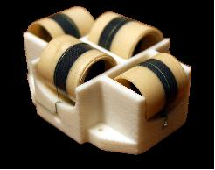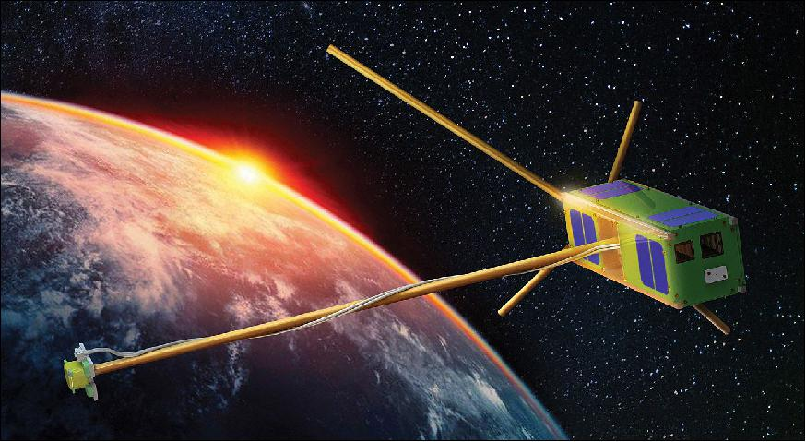

**Prototypes**

The first prototype utilized the hinge concept from the GOM design but reversed the hinge to open outwards. Because of this we needed the poles to bend and deploy straight since they were longer than the allotted footprint of the end cap. In our research and through talking to our sponsor, we found that a common antenna material for cubesats was simple tape measure spring steel. (he even used this material on his electrical prototypes for testing) The conductivity of the steel and the mechanical properties are ideal for deployment of antenna poles as the stored stresses cause deployment to a stable, straight, configuration using only material properties. The steel spring material was wrapped around a stabilization ring in the center and constrained with nylon burnwires. When these wires were caused to fail, the torsion springs mounted in the hinges rotated the poles upwards and into their deployed position while the materials of the tape spring caused the steel to snap into a straight configuration as seen in the second figure. We were also experimenting with C-1008 spring steel ribbon (supplied by dependable springs in Tigard) to minimize the height of the system but this was abandoned.

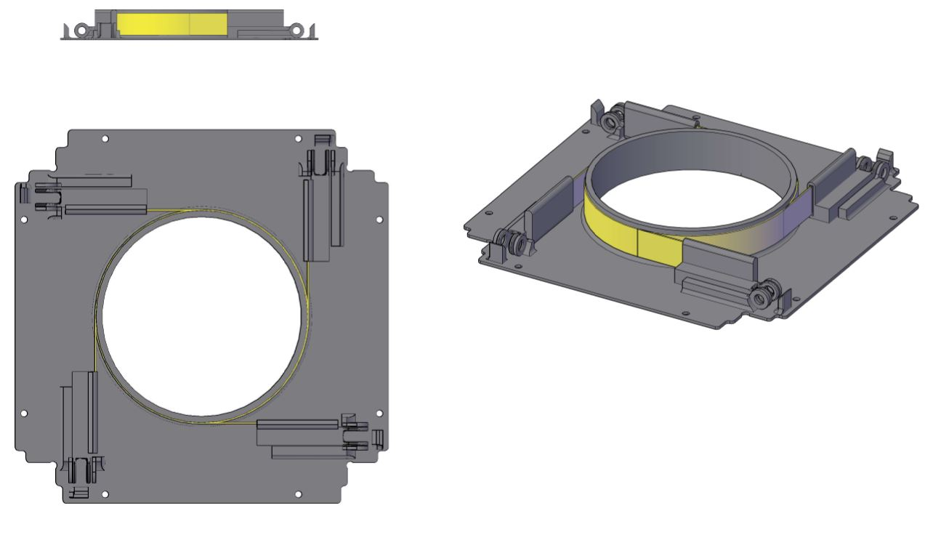 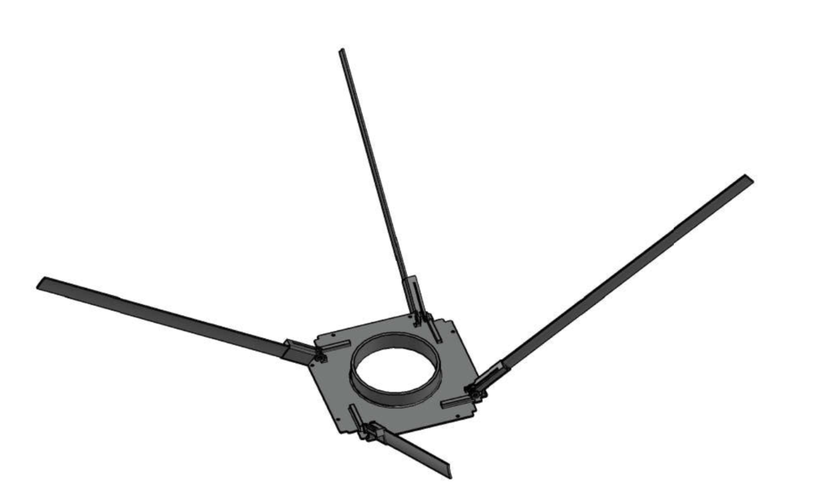

The second prototype that was developed in parallel also utilized the material properties of steel tape springs and combined them with the ELFIN prototype we saw before. The tape spring would be rolled up into a deployment structure and constrained by burn wires. When the burn wires break, the springs would deploy into a stable/straight configuration. This design was desirable because there are less moving parts and thus less opportunities for things to go wrong. The main challenge was rolling the springs to a radius that could fit within the vertical footprint. Even the larger 17mm height was challenging to achieve with steel springs.

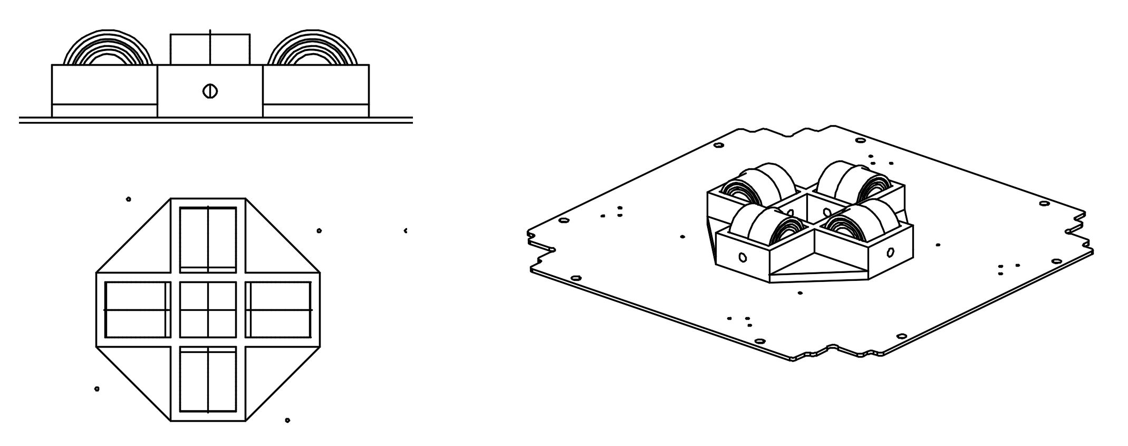

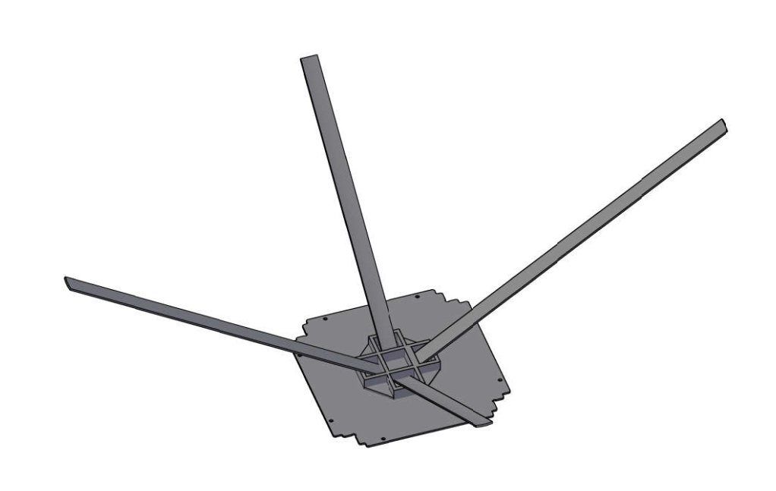

**Design Requirements Update/Current Design**

About halfway through the design process, our customer updated the design requirements of the turnstile quite drastically. They requested instead of a single conductive element per pole that there be 4 conductive wires in each of the four poles. In addition, they needed to be isolated from each other so we had to come up with a non-conductive structural element for our deployment method. The hinge design was discarded in favor of the spring rollup design, mostly due to the complicated nature of connecting four wires to the board through the micro-hinges and complexity of the deployment mechanism. Our most hopeful solution was found in the original ELFIN design. Our research led us down the path of non-conductive fiberglass tape springs that are used in several applications for CubeSats. This concept works quite similarly to the tape measure spring steel but is made from non-conductive material. The material we chose based on our research and requirements was e-glass fiberglass pre impregnated with epoxy resin. This graphic illustrates the stresses experienced in the tape spring as it transitions from the rolled up configuration with stored strain energy to the stable straight or deployed configuration at the top. By storing the tape spring between these two configurations, the spring will deploy to the first stable configuration.

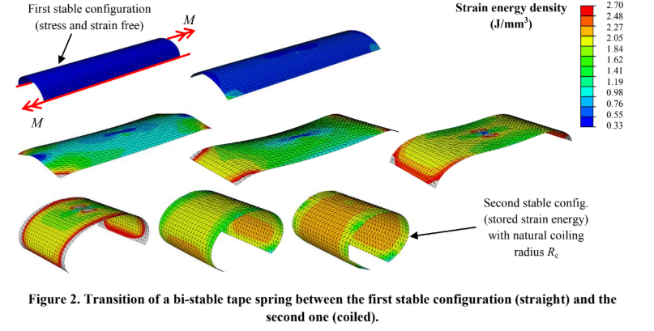

Another example showing exactly how this works is shown here: The rolled up tape spring transitions from configuration 2 to configuration 1 after burn wire activation.

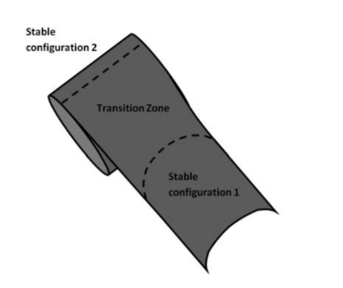

We designed a tape spring with a diameter of ½” which when rolled flat expanded to a width of .78” This meant our prototype deployment structure had to almost double in size.

Currently, we’ve manufactured several iterations of the composite tape springs using a vacuum bag cooking technique at the recommendation of the fiberglass manufacturer. The material chosen was plain weave with the e-glass threads in this configuration.

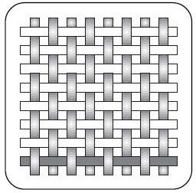

To deploy reliably, the e-glass has to be layered in the following orientations. [-45/0/90/45] The 45 degree orientation layers are what provide the stresses that deploy the tape spring. We’ve experimented with different layering but more work is required for exact material selection and different manufacturing processes need to be experimented with.

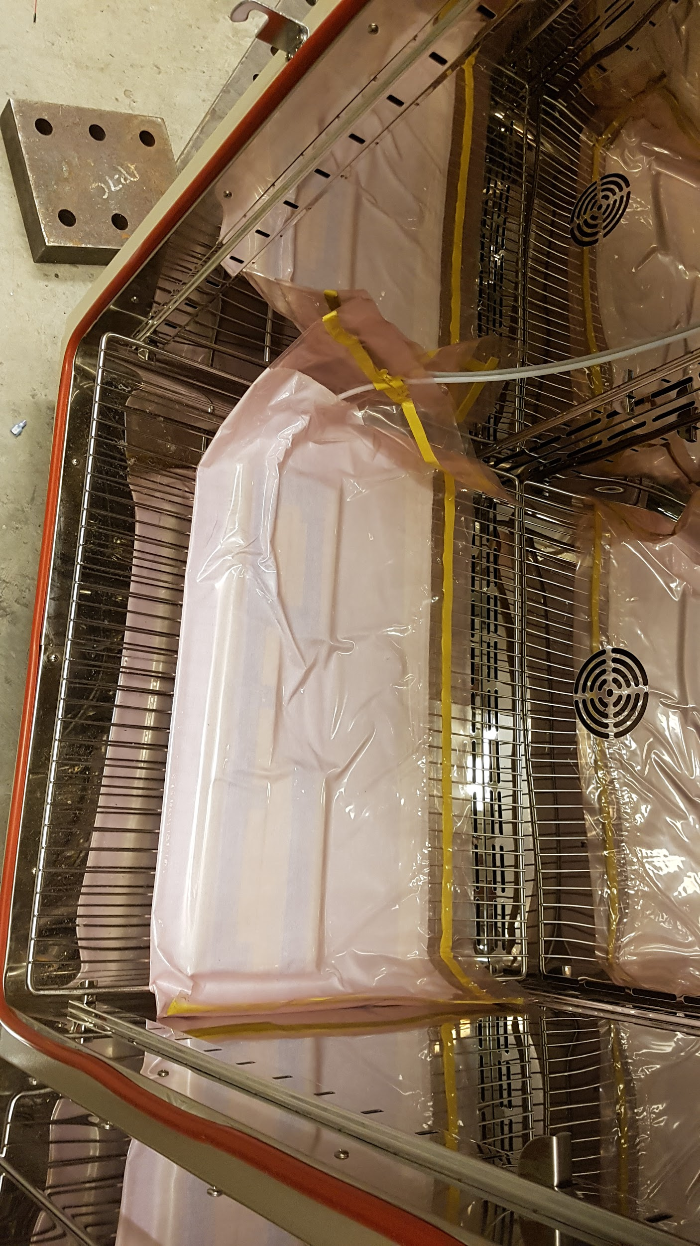

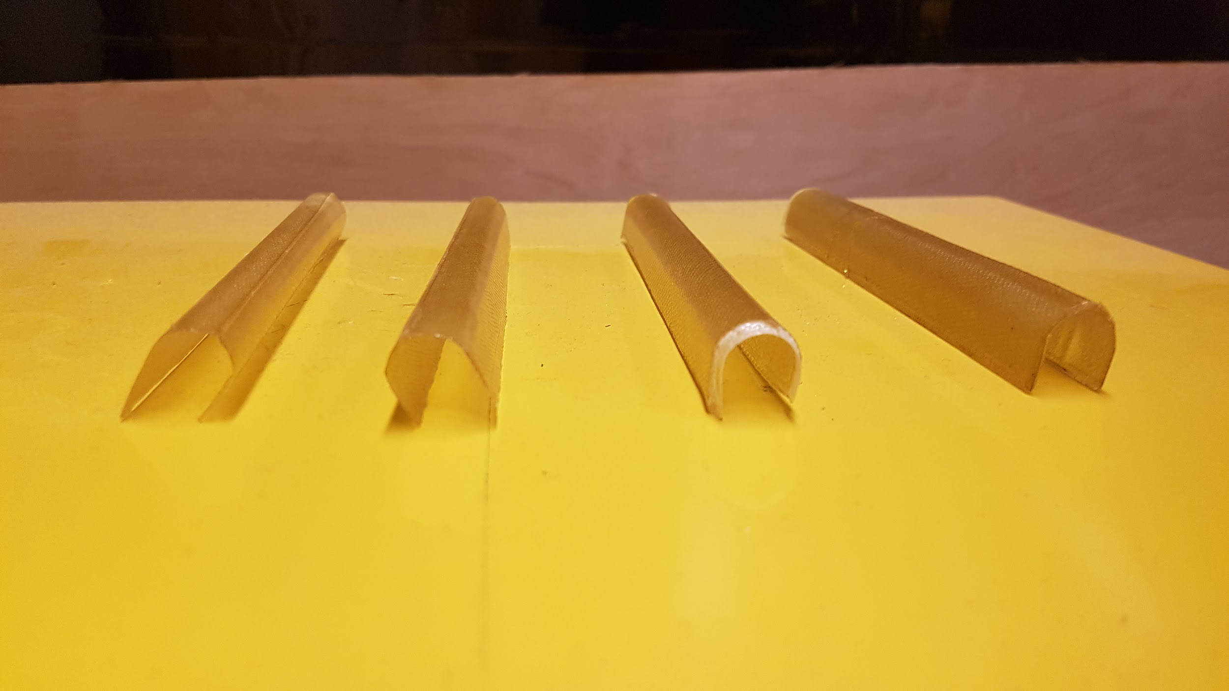

**Helical Antenna**

